RADAR using ARDUINO UNO and ULTRASONIC SENSOR

Abbb #1, Abnbvbv #2, Agggggg #3, Fggggg #4

Student, Student, Student, Student

*Dept. Of Computer Sciences and Engineering*

*Lovely Professional University, Phagwara(144411), Punjab India*

***Abstract*— *The development of a radar system using Arduino Uno and an ultrasonic sensor represents a significant advancement in object detection technology. This project aims to design a radar device capable of identifying objects within its range and providing immediate feedback. The challenges inherent in this endeavor include ensuring precision, real-time processing, and the integration of hardware and software to create a reliable detection system. To address these challenges, the project incorporates best practices such as iterative testing, modular design, and the application of signal processing algorithms. The successful implementation of this radar system can lead to enhanced situational awareness in various applications, from automotive safety features to security surveillance systems. As the project progresses, the focus on refining the radar's accuracy and response time is paramount. The commitment to continuous improvement and adaptation of emerging technologies will be crucial for the radar system to meet the evolving demands of object detection and response solutions.***

***Keywords—Radar, Arduino Uno, Ultrasonic Sensor, Object Detection, Response System, Bug Tracking, Stability, Security, IEEE Format***

INTRODUCTION

In an era marked by technological advancements and evolving security challenges, the role of home alarm systems has become paramount in ensuring the safety and protection of residential properties and their occupants. With the increasing instances of burglaries, intrusions, and safety hazards, the demand for robust security solutions that offer real-time monitoring, remote control capabilities, and integration with smart home technology has surged significantly. Home alarm systems have emerged as a critical component in addressing these security concerns by providing a proactive and comprehensive approach to safeguarding homes and enhancing the overall sense of security for homeowners.

The primary objective of a home alarm system is to deter unauthorized access, detect potential threats, and alert homeowners and authorities promptly. These systems are equipped with a range of sensors and devices such as motion detectors, door/window sensors, glass break sensors, smoke detectors, and carbon monoxide detectors. This multifaceted approach ensures comprehensive coverage of potential security risks, including intrusions, fire hazards, and environmental dangers, thereby enhancing the safety and well-being of residents.

One of the key features that distinguish modern home alarm systems is their ability to offer remote monitoring and control functionalities. Through the integration of advanced technologies such as GSM modules, Wi-Fi connectivity, and smartphone apps, homeowners can remotely access and manage their alarm systems from anywhere, at any time. This remote access empowers users to arm/disarm the system, receive real-time alerts and notifications, view live camera feeds, and check the status of sensors and devices, providing a heightened level of security awareness and control.

Moreover, the integration of home alarm systems with smart home technology has revolutionized the way homeowners interact with their security systems. These systems can seamlessly integrate with smart locks, lighting systems, thermostats, and other smart devices, enabling automated responses and coordinated actions based on security events. For instance, in the event of a detected intrusion, the system can automatically activate lights, lock doors, and send alerts to designated contacts, enhancing the overall security posture of the property.

Aside from the security benefits, installing a certified home alarm system can also lead to financial advantages. Many insurance companies offer discounts on homeowners' insurance premiums for properties equipped with certified alarm systems, incentivizing homeowners to invest in robust security solutions. Furthermore, home alarm systems come in a variety of configurations and customization options, allowing homeowners to tailor the system to their specific security needs, preferences, and budgetary constraints.

LITERATURE REVIEW

The literature on home alarm systems employing ultrasonic sensors and GSM modules reveals a dynamic landscape of technological advancements and practical implementations. Studies examining ultrasonic sensors in home security consistently highlight their effectiveness in detecting motion and proximity, contributing significantly to intrusion detection capabilities. Research on GSM module integration emphasizes the importance of remote monitoring, real-time alerts, and mobile connectivity, showcasing the reliability and convenience offered by cellular communication in home alarm systems. A notable trend in recent literature is the synergistic combination of ultrasonic sensors and GSM modules, which demonstrates enhanced security functionalities and responsiveness to security incidents. User feedback and experiences underscore the usability and satisfaction levels of these integrated systems, albeit with occasional challenges in false alarm reduction and power efficiency. The integration of these technologies with smart home platforms emerges as a promising direction, offering not only security enhancements but also automation and convenience benefits for homeowners. Looking ahead, future research is poised to address challenges, such as improving sensor accuracy, reducing false alarms, and optimizing energy consumption, to further enhance the efficacy and usability of home alarm systems utilizing ultrasonic sensors and GSM modules.

PROBLEM STATEMENT

Creating an effective home alarm system using and control via GSM connectivity is essential for real-time alerts and system management. Security measures, including encryption protocols and data privacy safeguards, must be implemented to protect user information. Scalability and customization options for adding sensors and adapting to different security needs enhance the system's flexibility. Finally, prioritizing user experience with intuitive interfaces and comprehensive support resources contributes to a successful and accessible home alarm system deployment using Arduino Uno and GSM modules.

SYSTEM DESIGN

A. Methodology of model development

Firstly, we focus on sensor integration, where ultrasonic sensors are connected to Arduino UNO. These sensors emit ultrasonic waves and capture their reflections, providing crucial data about the distances of nearby objects. Arduino UNO acts as the central processing unit, collecting and processing data from the ultrasonic sensors using a sophisticated algorithm. This algorithm calculates the time taken for the ultrasonic waves to travel to an object and back, allowing for accurate distance measurements.

The processed data is then transmitted to a display interface, which could be an LCD display or a graphical user interface (GUI) on a computer. This interface visually represents the detected objects and their respective distances, providing real-time monitoring of the surroundings. Users can interact with the radar system, adjusting detection ranges, setting alert thresholds, and receiving alerts or warnings when objects are detected within specified ranges.

B. Hardware Module Design

Hardware system consist of basically 3 components named as Arduino, servo-motor, and ultra-sonic sensor. Ultrasonic sensor is mounded upon a servo motor which helps it to move and provide it a turning mechanism. Both ultrasonic sensor and servo motor are controlled and powered by Arduino. The development of Radar system involves various steps such as design of different components, their testing and implementation.

HARDWARE DESCRIPTION

1. Ultrasonic Sensor

An ultrasonic sensor is a device that uses sound waves with frequencies higher than the human audible range (typically above 20 kHz) to detect objects and measure distances. It works on the principle of sending out ultrasonic pulses and measuring the time it takes for the pulses to bounce back after hitting an object. By calculating the time difference between sending and receiving the pulses, the sensor can determine the distance to the object with good accuracy. Ultrasonic sensors are commonly used in robotics, automation, parking assistance systems, and various other applications where non-contact distance measurement is needed. The ultrasonic sensors consist of two main components: a transmitter which is capable of transmitting the sound via piezoelectric crystals, and a receiver which receives the sound after it has travelled to or away from the target.

B. Arduino UNO

A microcontroller based on ATmega328P is called the Arduino UNO. It includes 14 digital input output pins, six of which can be used as PWM outputs, 6 analog inputs, a 16 MHz ceramic resonator, USB connection, power jack, ICSP header and reset button. It's packed with the components necessary to support the microcontroller, and you can simply connect it to your computer using a USB cable or charge it at its AC adapter or battery in order to get started. The Uno board was the successor of the Duemilanove release and was the 9th version in a series of USB-based Arduino boards.

1. Jumper Wires

Jumper wires are flexible electrical cables used in electronics. They have connectors at both ends and are often made of thin copper wire with insulation. They're handy for creating temporary connections between components on breadboards or circuit boards during testing or prototyping.

1. Servometer

A servomotor is a rotary actuator or motor that allows precise control of angular position, velocity, and acceleration. It operates based on feedback, meaning it adjusts its position based on signals it receives, typically from a controller. Servomotors are known for their ability to maintain a set position or move to a specified angle with high accuracy, making them essential components in robotics, automation, CNC machines, and various other applications where precise motion control is required. They often feature built-in gearing systems to achieve high torque output while maintaining compact size and are commonly used in conjunction with sensors and control systems for accurate positioning and movement tasks.

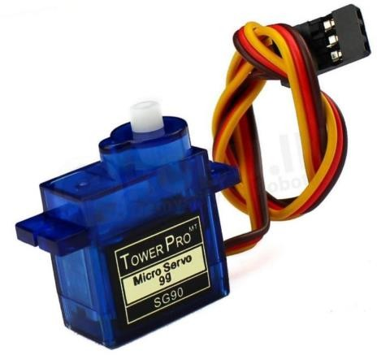

1. GSM Module

A GSM module is a vital component that facilitates communication over cellular networks, serving as a crucial interface between electronic devices and the GSM network. At its core lies the modem, responsible for encoding, decoding, and managing data transmission over the radio interface. These modules typically require a SIM card, containing essential user and network credentials, to connect to the network. They often feature an antenna connector for improved signal reception, operate on specific power requirements, and communicate with host devices through serial interfaces using standardized AT commands. Additionally, they support data communication protocols like GPRS or EDGE, enabling internet connectivity and may integrate features such as GPS functionality and digital I/O pins for expanded functionality. Widely used across IoT, tracking systems, and security applications, GSM modules offer versatile wireless communication capabilities essential for modern connectivity needs.

HARDWARE WORKING

A radar system built using an Arduino Uno, a breadboard, and an ultrasonic sensor operates on the principle of sonar. The ultrasonic sensor emits sound waves that travel through the air and bounce back upon encountering an object. These reflected waves are then captured by the sensor, which calculates the time interval between sending the wave and receiving the echo. The Arduino Uno, programmed through the Arduino IDE, processes this data to determine the distance of the object from the sensor. By rotating the sensor using a servo motor, the system can scan a wide area to detect objects in various positions. The processed information is then displayed on a screen, providing real- time data on the location and movement of the object within the sensor's range.

1. SOFTWARE OVERVIEW

The Arduino software, also known as the Arduino IDE (Integrated Development Environment), is a fundamental tool for programming Arduino microcontrollers. It provides a user-friendly platform that simplifies the process of writing, compiling, and uploading code to Arduino boards, making it accessible to both beginners and experienced developers. . It operates on the Java Platform, which is easily accessible for operating systems like Windows, MAC, and Linux. This platform has inbuilt tools, functions and commands that are essential for debugging, modifying, and compiling the code in the environment. Both C++ and C are supported in this environment. Additionally, as an open- source tool, Processing offers a comprehensive programming environment and a free visual library. Java is the coding language used by Processing, although it has been further simplified by the addition of accessible methods and procedures. Additionally, a GUI interface is offered for simple compilation and execution. When you combine Processing with the Arduino IDE, you can make a visual or graphical representation of how the code is run in the IDE

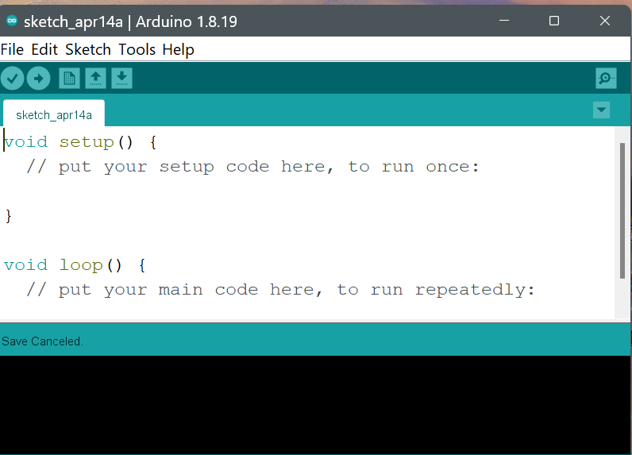

Fig.6 Arduino IDE

1. SOFTWARE IMPLEMENTATION

The void function consists of an important function that measures the distance with the use of an ultrasonic sensor. The speed of the ultrasonic is 0.034 m/s multiplied by the duration and the whole value is divided by two because the distance travelled by the wave is twice the original distance

due to the reflection of the wave. Another major part of the code consists of an IF-Else statement which is used for the turning of the servo motor at an angle of 180 degrees from the initial point. The input for the servo-motors is the distance measured by the ultrasonic sensor. If the distance measured by the sensor is less than the threshold value the servomotor rotates and scans for objects in its range. The angle of detection of the servo motor that mounts the ultrasonic sensor is assigned to the turret’s servo motor to aim the target object. The Arduino is interfaced with Processing software, where the function Serial. Print () is used to transfer the distance read by the ultrasonic sensor to Processing software via a USB cable. Processing software is used for the graphical representation of the radar. There are pre-defined functions in the software such as void drawLine(), and void drawObject() used to outline the radar as shown in figure 4. The real-time input is fed in by Port = new Serial(), where the ports are defined by the user.

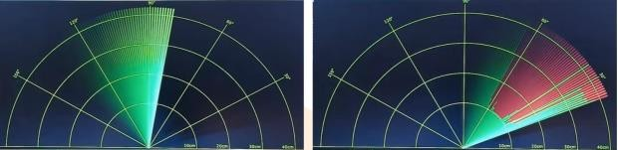

Fig.7 working of radar

1. EXECUTION OF MODEL

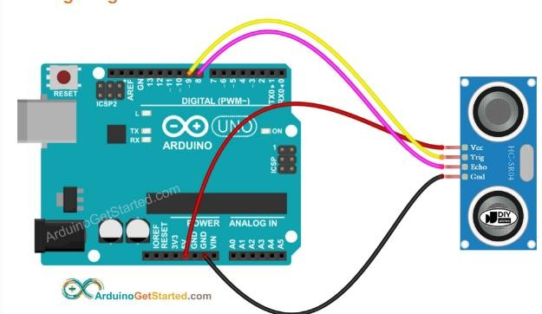Followed by the implementation of software and the system design the final hardware working is proceeded by an ultrasonic sensor is mounted on a servo motor, which enables it to create an angular range for detection as the servo motor rotates. A prototype of a turret is mounted on another servo motor to create an automatic aiming system to eliminate the target. First, the ultrasonic sensor scans at a proximity of 20 cm with an angle of 120 degrees. The ultrasonic sensor detects an object which has entered the proximity zone, the turret targets the object and the distance and angle of detection are shown on the computer screen.[10]

Fig.8 connection image [7]

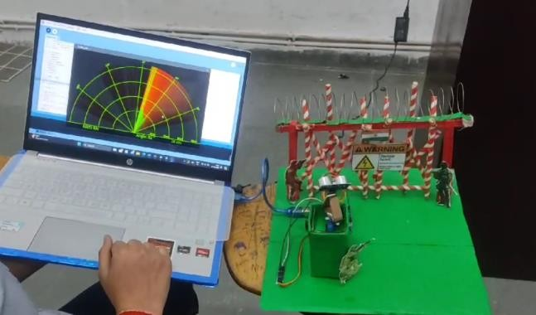

Fig.9 working model showing red when

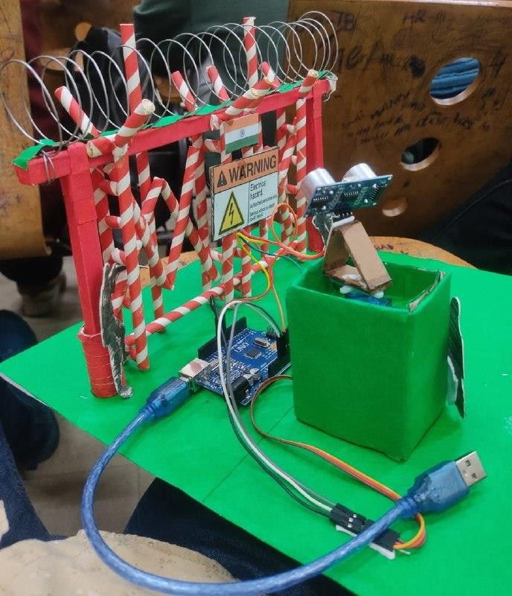

detects some object

Fig.10 model when not plugged in pc

1. 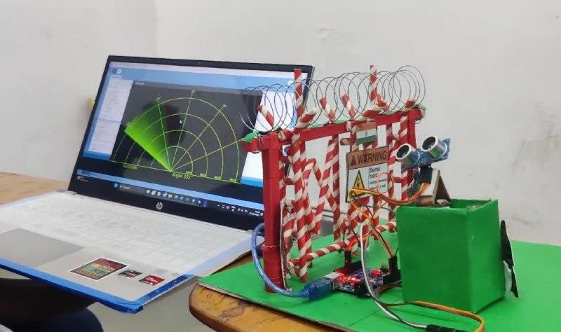ADVANTAGES

Fig.11 working model showing green when doesn’t detect any object

Fig.12 Virtual terminal result

One significant advantage of using an ultrasonic sensor in radar applications is its independence from color and transparency. Unlike some optical sensors that may be influenced by an object's color or transparency, ultrasonic sensors rely on sound waves, making them impervious to such visual properties. This ensures consistent and reliable performance regardless of the object's appearance. Furthermore, ultrasonic sensors are relatively easy to design into radar systems at a low cost. The market offers a wide range of components, including affordable ultrasonic sensors, facilitating the development of radar systems without breaking the bank.

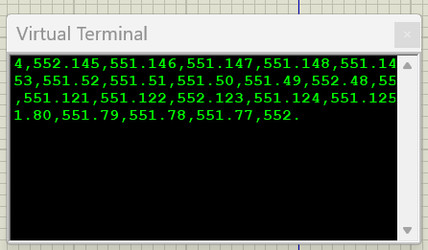Additionally, these sensors are resilient to environmental factors like dust and dirt, maintaining their functionality even in challenging conditions. This robustness makes ultrasonic sensors a practical choice for radar applications where consistent performance and cost-effectiveness are essential considerations.

1. APPLICATION

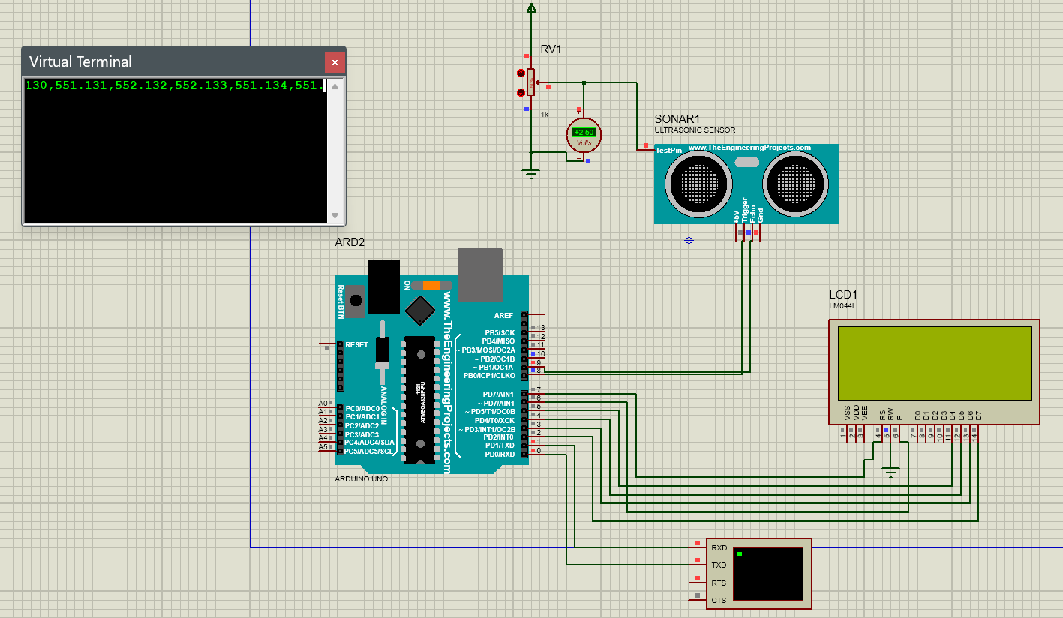While observing the technology employed by the military,

whether it be the Army, Navy, or Air Force, the concept of an ultrasonic radar first came to us. Aerial Force In aviation, airplanes are outfitted with radar equipment that provides

accurate altitude measurements, displays weather information, and warns of aircraft or other impediments in or near their route. The anti-aircraft defence system's primary function is to detect unauthorized flights in surveillance zones or other areas where they are not permitted.

1. CONCLUSION

In conclusion, the integration of Arduino and GSM module technology offers a highly effective and versatile solution for creating a home alarm system. By harnessing the power of Arduino's programmability and the connectivity provided by GSM modules, users can design custom alarm systems tailored to their specific needs and preferences. Whether it's detecting intrusions, monitoring environmental conditions, or providing remote access and control, the combination of these technologies enables comprehensive security and peace of mind for homeowners. Additionally, the modularity and expandability of Arduino-based systems allow for easy integration with other sensors and devices, further enhancing the system's functionality. With its affordability, accessibility, and flexibility, the Arduino-GSM home alarm system represents a significant advancement in DIY home security solutions, empowering individuals to take control of their safety with innovative and customizable technology.

REFERENCES

1. A. Bochare and M. Saini, \**Short range radar system using Arduino Uno*,* International Research Journal of Engineering and Technology (IRJET), vol. 4, no. 6, pp. 335-338, 2017.
2. A. Tedeschi, S. Calcaterra, and F. Benedetto, *\*Ultrasonic radar system (URAS): Arduino and virtual reality for a light-free mapping of*

*indoor environments*,* IEEE Sensors Journal, vol. 17, no. 14, pp. 4595- 4604, 2017.

1. D. A. Ghoghre, A. Dhanshri, and A. Priyanka, \**Radar system using Arduino*,* in National conference on emerging trends in engineering & technology, pp. 53-56, 2017.
2. S. Mehta and S. Tiwari, *\*Radar system using Arduino and ultrasonic sensor*,* International Journal of Novel Research and Development, vol. 3, no. 4, pp. 14-20, 2018.
3. N. I. Abdulkhaleq, I. J. Hasan, and N. A. J. Salih, *\*Investigating the resolution ability of the HC-SRO4 ultrasonic sensor*,* in IOP Conference Series: Materials Science and Engineering, vol. 745, no. 1, p. 012043, February 2020.
4. https://[www.youtube.com/watch?v=ZHc1IZ7pw_8](http://www.youtube.com/watch?v=ZHc1IZ7pw_8)
5. https://arduinogetstarted.com/tutorials/arduino-ultrasonic-sensor
6. L. Manimegalai, S. H. Rose, and B. Abinaya*, *Enhanced Military Spying Sonar Radar System using Ultrasonic Sensor*,* in 2022 International Conference on Computer Communication and Informatics (ICCCI), pp. 1-4, January 2022.
7. H. R. Hatem, A. I. Abdalla, and Z. N. A. Al-Rawi, \**Design and implementation of ultrasonic radar system for distance measurements using Arduino\**, International Journal of Engineering & Technology, vol. 7, no. 4, pp. 3115-3118, 2018.
8. https://[www.theengineeringprojects.com/2015/02/ultrasonic-](http://www.theengineeringprojects.com/2015/02/ultrasonic-) sensor-library-proteus.html